1) Create Database
MySQL create database is used to create a database.
create database college;

2) Select/Use Database
MySQL use <database> is used to select a database.
use college;

3) Create Query
MySQL create query is used to create a table,
CREATE TABLE customers
(id int(10), name varchar(50), city varchar(50), PRIMARY KEY (id ) );
Using foreign key:
CREATE TABLE customerInfo
(id int(10), name varchar(50), city varchar(50), PRIMARY KEY (id ), FOREIGN KEY( id) REFERENCES Table_Name(field_Name) );

4) Alter Query
MySQL alter query is used to add, modify, delete or drop columns of a table. Let's see a query to add column in customers table:
ALTER TABLE customers
ADD age varchar(50);

5) Insert Query
MySQL insert query is used to insert records into table
insert into customers values(101,'rahul','delhi');

6) Update Query
MySQL update query is used to update records of a table.
update customers set name='bob', city='london' where id=101;

7) Delete Query
MySQL update query is used to delete records of a table from a database.
delete from customers where id=101;

8) Select Query
Oracle select query is used to fetch records from the database.
SELECT * from customers;
9) Truncate Table Query
MySQL update query is used to truncate or remove records of a table. It doesn't remove structure.
truncate table customers;
10) DROP Table
MYSQL uses a Drop Table statement to delete the existing table. This statement removes the complete data of a table along with the whole structure or definition permanently from the database
drop table customers;
11) JOIN tables

SELECT table1.OrderID, table2.CustomerName, table1.OrderDate
FROM table1
INNER JOIN table2 ON table1.CustomerID=table2.CustomerID;
12) Searching for Null values in the DB
Select * from INDIANTEAM WHERE passowrd is not Null;
13) Search use partial values
Select * from INDIANTEAM where firstName like '%T';
/* ‘%’ is a wildcard and it accepts anything - do search for a name starting with ‘D’ then
Use ‘D%’ to search, to search for a name ending with ‘D’ then use ‘%D’

Create database retailsite;

Use retailsite;
CREATE TABLE userinfo
(gender varchar(20),
firstName varchar(20),
lastName varchar(20),
emailId varchar(20),
password varchar(20),
confirmPassword varchar(20),
customerId int(15),
primary key (customerId) );

Use retailsite;
CREATE TABLE orders
(orderNum int(20),
customerId int(15),
primary key(orderNum), foreign key(customerId) references userinfo(customerId));

Select * from orders;
Select * from userinfo;

ALTER TABLE userinfo add city varchar(20);

ALTER TABLE userinfo modify emailId varchar(30);

Insert into userinfo values ('female', 'Sara', 'A', 'Sara.A001@test23.com', 'Password123', 'Password123', 78823, 'Chennai'),
('male', 'Sachin', 'R', 'Sachin.R2@test23.com', 'Password123', 'Password123', 78824, 'Mumbai'),
('male', 'Rahul', 'D', 'Rahul.D3@test23.com', 'Password123', 'Password123', 78825, 'Banglore'),
('male', 'Yuvi', 'S', 'Yuvi.A004@test23.com', 'Password123', 'Password123', 78826, 'Pune'),
('male', 'Gill', 'S', 'Gill.A005@test23.com', 'Password123', 'Password123', 78827, 'Dehli'),
('female', 'Vinaya', 'A', 'Vinaya.A6@test23.com', 'Password123', 'Password123', 78828, 'Kochin'),
('female', 'FirstName794', 'X', 'First794.X1@test23.com', 'Password123', 'Password123', 78829, 'Chennai'),
('female', 'FirstName795', 'R', 'First795.R1@test23.com', 'Password123', 'Password123', 78830, 'Chennai'),
('female', 'FirstName796', 'T', 'First796.T1@test23.com', 'Password123', 'Password123', 78831, 'Chennai');

Update userinfo set gender ='female' where customerId = '78823';

Insert into orders values (202507001,78823),
(202507002,78824),
(202507003,78825),
(202507004,78826),
(202507005,78827),
(202507006,78828),
(202507007,78829),
(202507008,78830),
(202507009,78831),
(202507010,78823),
(202507011,78824),
(202507012,78825),
(202507013,78826),
(202507014,78827),
(202507015,78828),
(202507016,78829),
(202507017,78830),
(202507018,78831),
(202507019,78823),
(202507020,78824),
(202507021,78825),
(202507022,78826),
(202507023,78827),
(202507024,78828),
(202507025,78829),
(202507026,78830),
(202507027,78831);

Delete from orders where orderNum =202507027;

Select * from orders where orderNum =202507027;

truncate table orders;

drop table orders;

Select firstName, emailId, userinfo.customerId, orders.orderNum from userinfo Inner join orders on userinfo.customerId=orders.customerId;

Select * from userinfo;

Select * from userinfo where firstName like 'S%';

Select * from userinfo where firstName like '%l';

Select * from userinfo where firstName like '%r%';

Create table dummy (result char(4))

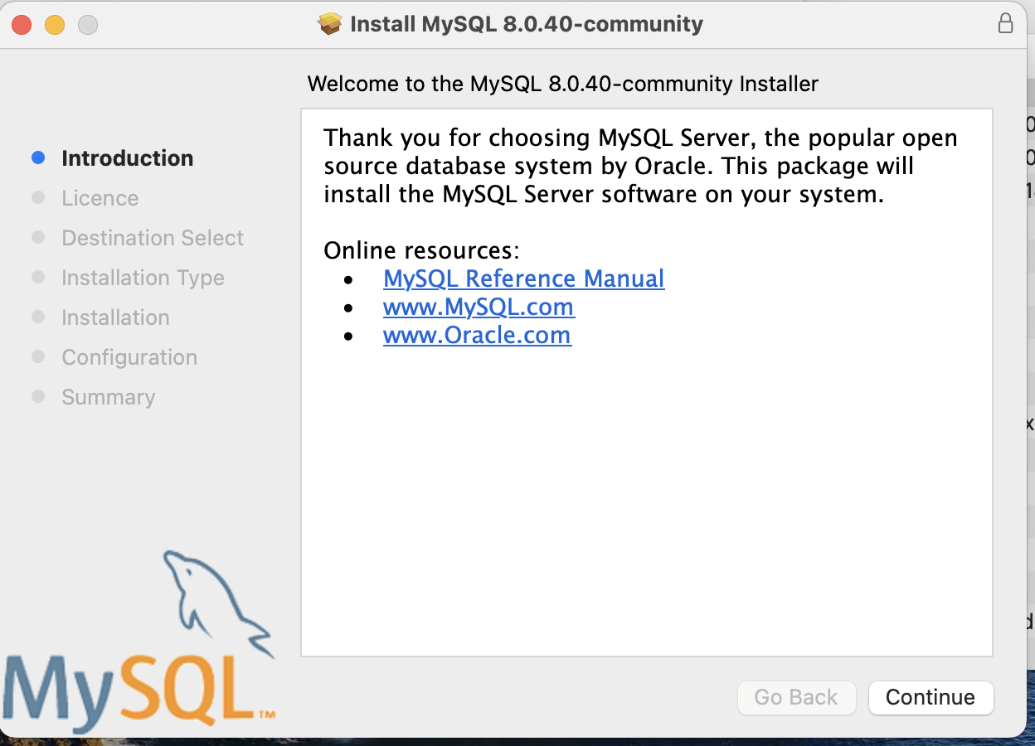

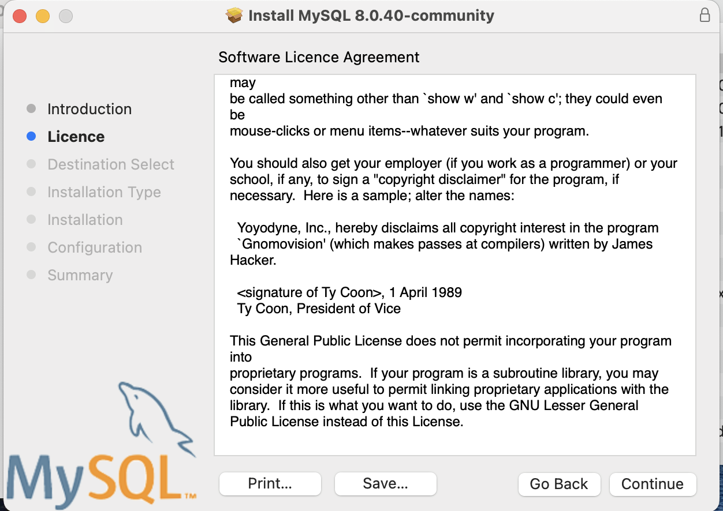
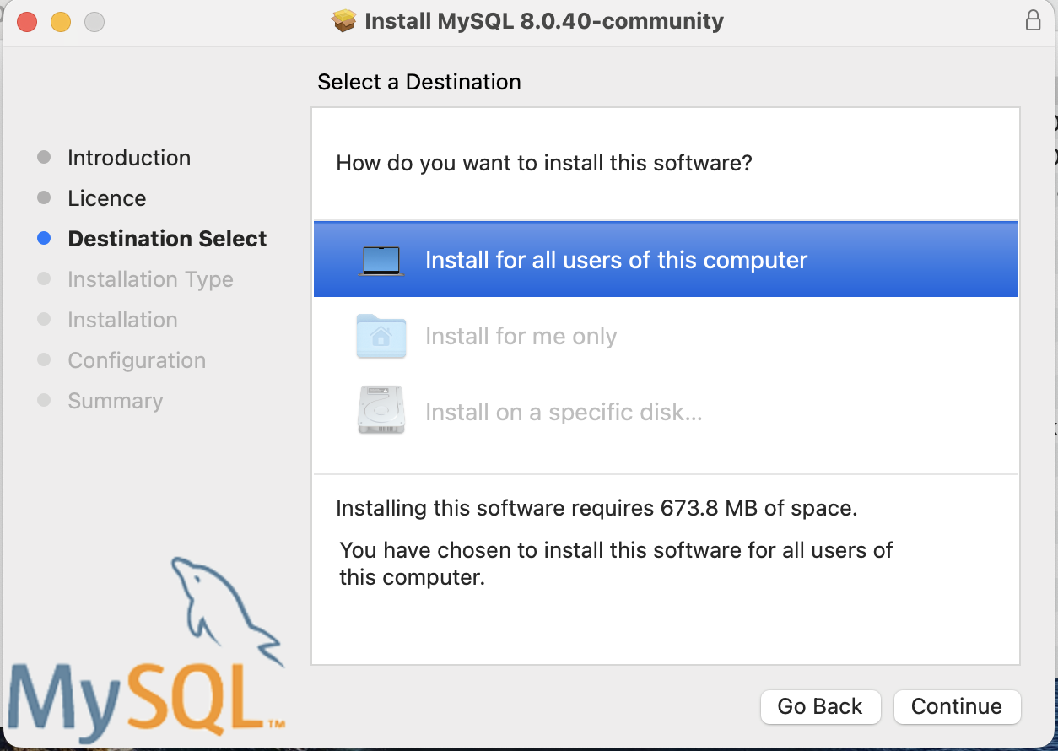
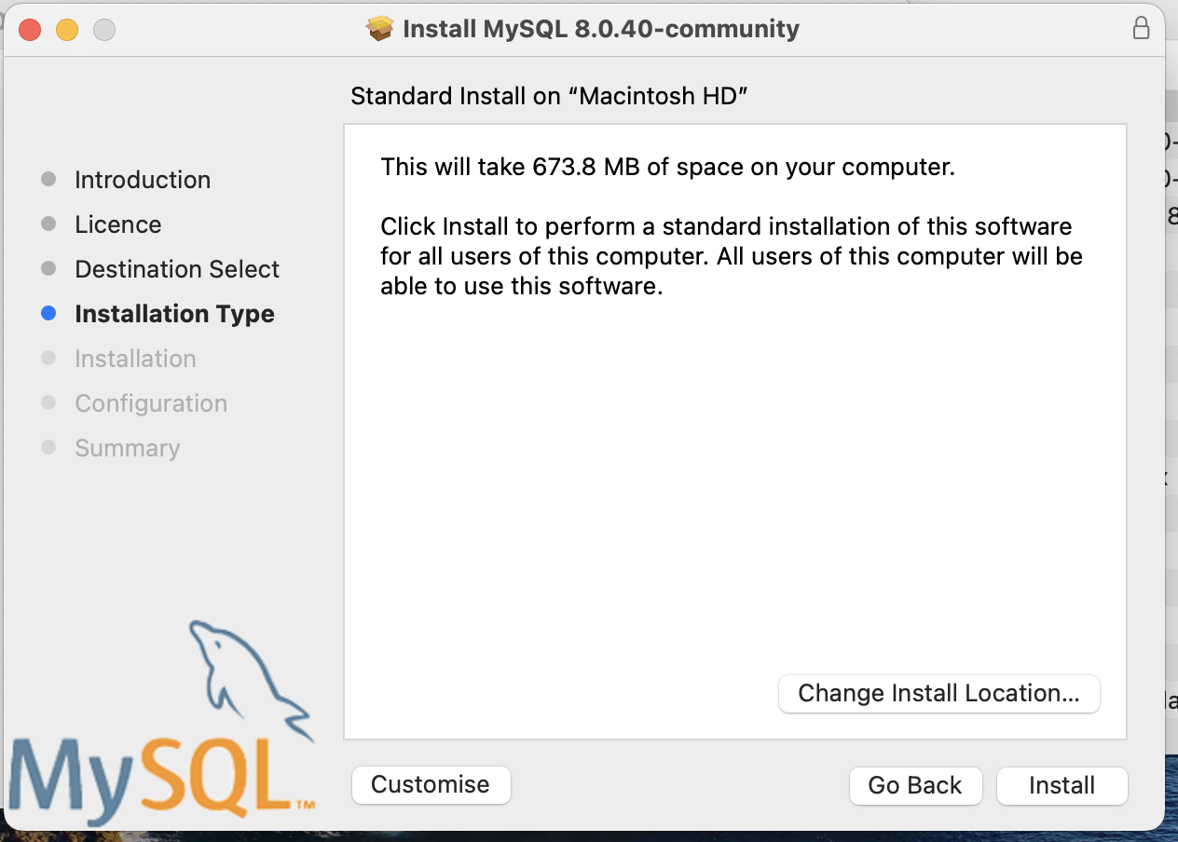
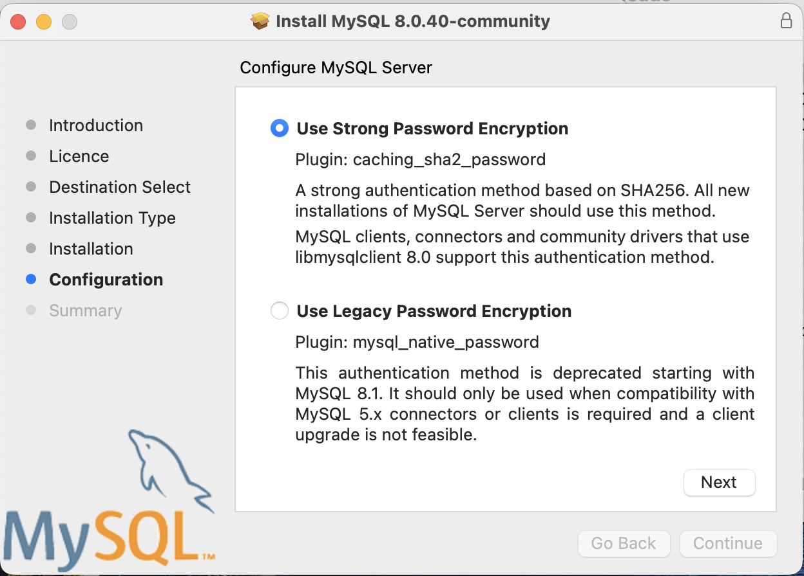
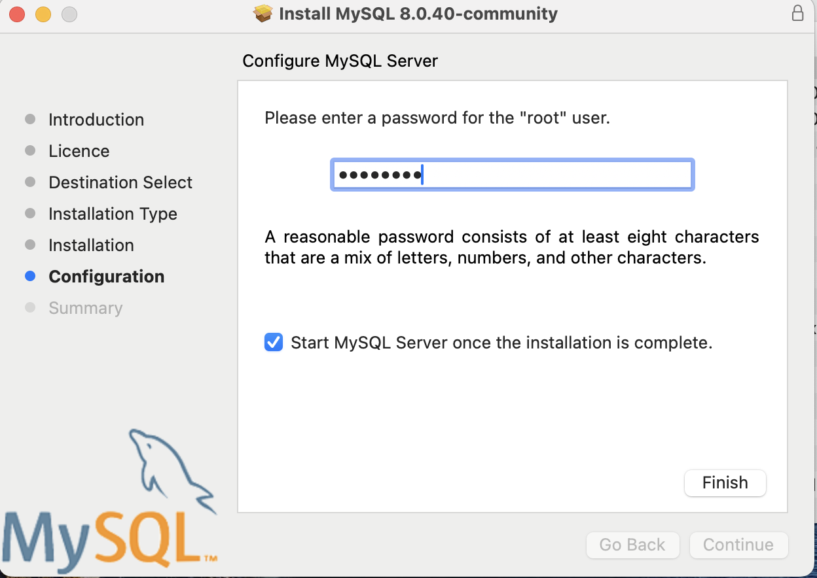


CREATE DATABASE COLLEGE;
USE COLLEGE;
CREATE TABLE DEPARTMENTS (DEPT_NO int(10), DEPT_NAME varchar(20), HOD_NAME varchar(20), PRIMARY KEY(DEPT_NO));
USE COLLEGE;
CREATE TABLE STUDENTSINFO (STUDENT_ID int(10), STUDENT_NAME varchar(20), DEPT_NO int(10), CITY varchar(20),
PRIMARY KEY(STUDENT_ID), FOREIGN KEY(DEPT_NO) REFERENCES DEPARTMENTS(DEPT_NO) );
ALTER TABLE STUDENTSINFO ADD AGE int(10);
SELECT AGE, STUDENT_NAME FROM STUDENTSINFO;
SELECT * FROM STUDENTSINFO where AGE >= 19;
SELECT * FROM DEPARTMENTS;
INSERT INTO DEPARTMENTS (HOD_NAME, DEPT_NAME, DEPT_NO) VALUES
('ASHOK', 'ECE', 3),
('NIRMALA', 'BTECH.IT', 4),
('RAJESH', 'CIVIL', 5),
('PRAVEEN', 'MECH', 6);
INSERT INTO STUDENTSINFO VALUES(1, 'AJAY', 2, 'DEHLI', 19),
(2, 'VIJAY', 2, 'DEHLI', 19),
(3, 'SANJAY', 1, 'KOKATTA', 18),
(4, 'SAMSON', 3, 'CHENNAI', 19),
(5, 'SARA', 4, 'CHENNAI', 19),
(6, 'SANGEETHA', 5, 'HYDERABAD', 18),
(7, 'SOWMIYA', 5, 'DEHLI', 20),
(8, 'VIVEK', 1, 'CHENNAI', 19),
(9, 'AJAY', 2, 'HYDERABAD', 18),
(10, 'RAHUL', 3, 'BANGALORE', 19),
(11, 'RAJESH', 4, 'BANGALORE', 18),
(12, 'RIYA', 5, 'MUMBAI', 20);
SELECT * FROM STUDENTSINFO INNER JOIN DEPARTMENTS ON STUDENTSINFO.DEPT_NO = DEPARTMENTS.DEPT_NO;

USE COLLEGE;
UPDATE STUDENTSINFO SET CITY='KOLKATTA' WHERE STUDENT_ID =3;
DELETE FROM STUDENTSINFO WHERE STUDENT_ID =3;
TRUNCATE TABLE STUDENTSINFO;
DROP TABLE STUDENTSINFO;

USE COLLEGE;
CREATE TABLE INDIANTEAM (firstName varchar(20), lastName varchar(20), email varchar(20), passowrd varchar(20), confirmPassword varchar(20), PRIMARY KEY(email));

SELECT * FROM INDIANTEAM where email ='PANT@bcci2411.com';

INSERT INTO INDIANTEAM VALUES( 'Yuvi', 'Singh', 'Yuvi@bcci2411.com', 'YouKnowMe123', 'YouKnowMe123'),
( 'DHONI', 'MS', 'DHONI@bcci2411.com', 'YouKnowMe123', 'YouKnowMe123'),
( 'VIRAT', 'K', 'VIRAT@bcci2411.com', 'YouKnowMe123', 'YouKnowMe123'),
( 'ROHIT', 'S', 'ROHIT@bcci2411.com', 'YouKnowMe123', 'YouKnowMe123'),
( 'PANT', 'R', 'PANT@bcci2411.com', 'YouKnowMe123', 'YouKnowMe123');

INSERT INTO INDIANTEAM VALUES( 'Yash', 'Jaiswal', 'Jaiswal@bcci2411.com', NULL, 'YouKnowMe123');

Select * from INDIANTEAM WHERE passowrd is Null;

Select * from INDIANTEAM WHERE passowrd is not Null;

/* firstName lastName email passowrd confirm Password

